Drawing Given circuit on LTspice:

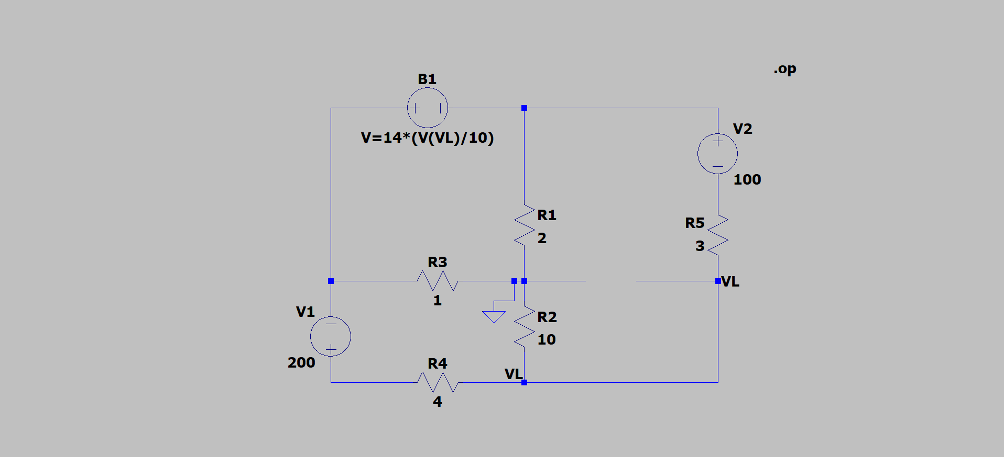

I-V characteristic of the given circuit:

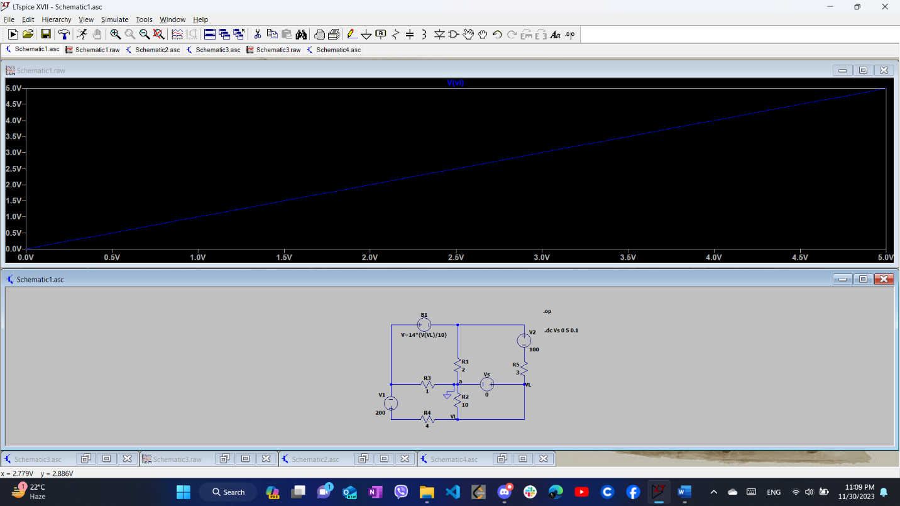

Vth = 18.1818V

Rth = 1.515 ohm

I-V characteristic of the Thevenin’s equivalent circuit:

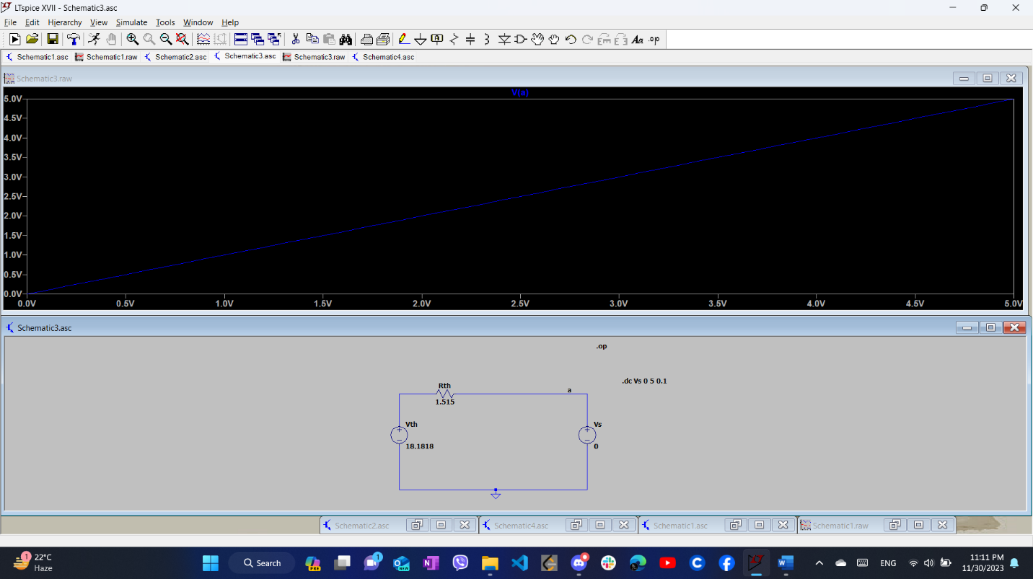

Thevenin’s equivalent circuit:

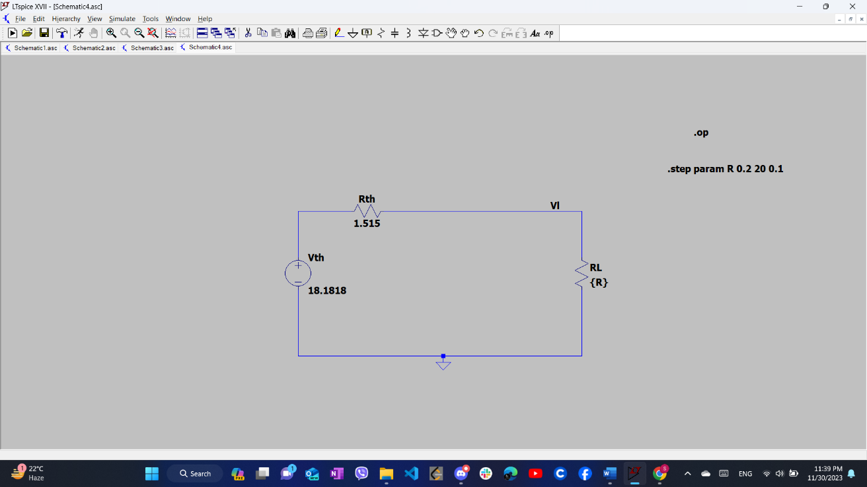

Maximum power transfer theorem using LTspice:

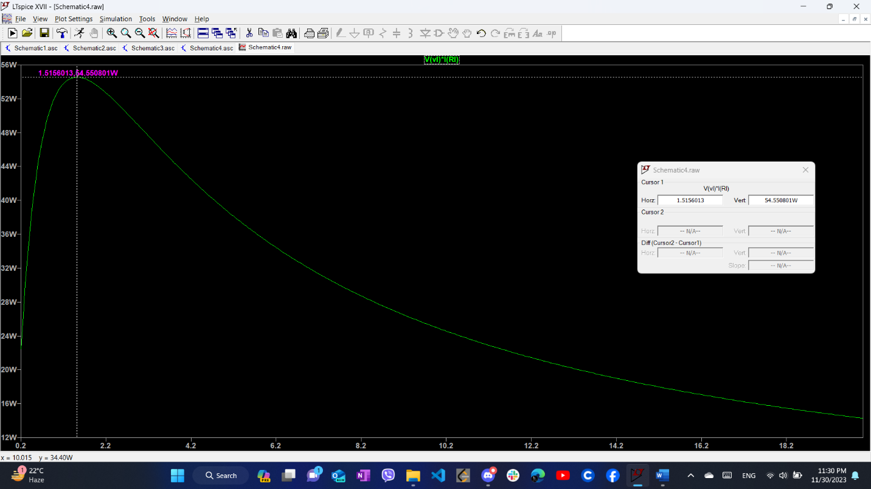

Vth = 18.1818V

Rth = 1.515 ohm

Pmax = (Vth)\*(Vth)/ (4\*Rth)

= 18.1818 \* 18.1818/(4\*1.515)

= 54.55W